A PROJECT REPORT ON

SCL
Automated Network Asset Reconciliation System
A Web-Based Tool for Reconciling Live Network Scans with Asset Inventory Records

Submitted in partial fulfilment of the requirements for the award of the degree of
BACHELOR OF TECHNOLOGY
in Computer Science & Engineering

Submitted By
Ravikant Bedi
4th Year, B.Tech (CSE) | University Roll No.: ___________

Under the Guidance of
Mr. / Ms. ___________________, Project Guide, SCL

DEPARTMENT OF COMPUTER SCIENCE & ENGINEERING
[ YOUR COLLEGE / UNIVERSITY NAME ]
2026

CERTIFICATE
This is to certify that the project report entitled “SCL – Automated Network Asset Reconciliation System” is a bona fide record of the work carried out by Ravikant Bedi, a student of B.Tech (Computer Science & Engineering), 4th Year, during the academic year 2025–26, in partial fulfilment of the requirements for the award of the degree of Bachelor of Technology.
The work embodied in this report has been carried out under my supervision and guidance and, to the best of my knowledge, has not been submitted elsewhere for the award of any other degree or diploma.

________________________
Project Guide
Department of Computer Science & Engineering
[ College / University Name ]

________________________
Head of Department

ACKNOWLEDGEMENT
I want to thank SCL for giving me the chance to work on this project, and for giving me real data — the network scan exports and inventory sheets — that shaped every decision I made while building this system.
I am very grateful to my Project Guide for their constant guidance, patient code reviews, and helpful suggestions throughout this project. Their feedback on the matching logic and the report formatting pushed me to write cleaner and safer code than I would have written on my own.
I also want to thank the Head of the Department and all the faculty members of the Department of Computer Science & Engineering for their support, and for giving me the space to turn a rough script into a properly built, containerised web application.
Finally, I want to thank my family and friends for their support during the long debugging sessions that a project like this always needs.

Ravikant Bedi

ABSTRACT
Companies with large networks usually keep two separate records of the devices connected to them. One is a live network scan, which shows what is actually connected right now. The other is an Excel inventory sheet, updated by hand, which is supposed to list every device the company owns. In real life, these two records never stay in sync. New laptops join the network before anyone adds them to the inventory. Old computers stay listed in the sheet long after they have been removed. To make things worse, the same MAC address can be written in five different formats across different files. Comparing these two records by hand in Excel, row by row, takes hours and is easy to get wrong. It also has to be done again and again, every audit cycle.
This project, SCL – Automated Network Asset Reconciliation System, is a web application that does this comparison automatically. The user uploads three files through a simple browser dashboard: a TXT file from the network scan, an Excel inventory sheet, and a small sheet that maps IP addresses to the name of the person using that device. The system cleans up all three files and compares them using IP address and MAC address together as the matching key. The backend is built with FastAPI and uses a fast dataframe library called Polars to join large files quickly. It also has a smart column-matching system, so it does not matter if a sheet’s column is called “IP-Address”, “ip_address”, or “IPAdd” — the system understands all of them as the same thing.
Every device record ends up in one of three groups: Matched (found in both files), Category A (in the inventory but not seen on the network), or Category B (seen on the network but missing from the inventory). The user can also set a time filter (1, 2, 3, or 6 months) to ignore old, stale records, and the system can exclude known IP/MAC ranges that are not useful, like loopback addresses. In the end, the tool creates six clean, well-formatted Excel reports that a network administrator can use directly, along with a quick summary shown on screen.
The whole application runs inside Docker and can be hosted on Ubuntu behind an Apache server. Every upload gets its own private session folder, so files from different users never mix. The core logic is also covered by automated tests. Overall, this project turns a manual job that used to take hours into a simple drag-and-drop upload that finishes in a few seconds.

Keywords: Network Asset Management, Data Reconciliation, FastAPI, Polars, Excel Automation, IP/MAC Matching, Python, Docker.

List of Figures
Figure 1: High-level three-tier system architecture 13
Figure 2: Project module map (app/ package structure) 14
Figure 3: Detailed data-processing pipeline 15
Figure 4: Reconciliation outcome Venn diagram & report outputs 16
Figure 5: Deployment view (Docker + Apache on Ubuntu) 17
Figure 6: Ten-stage development timeline 24
Figure 7: Production deployment topology 29

Table of Contents
CERTIFICATE 2
ACKNOWLEDGEMENT 3
ABSTRACT 4
List of Figures 5
Chapter 1. Introduction 7
Chapter 2. Existing System & Literature Review 9
Chapter 3. Requirement Analysis 10
Chapter 4. System Design 13
Chapter 5. Implementation 18
Chapter 6. Development Journey — From Start to End 23
Chapter 7. Testing 27
Chapter 8. Deployment 29
Chapter 9. Results & Discussion 31
Chapter 10. Conclusion & Future Scope 33
References 34

Chapter 1. Introduction

1.1 Background
Any organisation that runs its own network faces one quiet but constant problem: knowing exactly what devices are connected to it. Network teams regularly export live scan data — IP addresses, MAC addresses, hostnames — from switches, agents, or scanning tools. At the same time, the IT/asset team keeps an Excel sheet that is supposed to list every device the company owns, along with details like computer name, assigned user, system model, and the last time each machine talked to the monitoring agent.
In theory, these two records should always match. In practice, they drift apart all the time. Laptops get swapped between employees without anyone updating the sheet. New desktops get connected to the network days before they are added to the inventory. Old machines get removed but are never marked as retired. On top of this, the raw data itself is messy — the same MAC address might be written as “AA:BB:CC:DD:EE:FF” in one file and “aabb.ccdd.eeff” in another, and column names change depending on who last edited the sheet.
This project was built during my time working with SCL, where I was asked to help automate this exact comparison step. Until then, the network team had been doing it by hand in Excel, using VLOOKUP formulas and a lot of manual copy-pasting.

1.2 Problem Statement
Given a live network export (a raw TXT file from a scanning tool) and an Excel inventory maintained separately by the asset team, there was no fast and reliable way to answer three simple questions every audit cycle:
- Which devices are active on the network but missing from the official inventory (unregistered devices)?
- Which devices are listed in the inventory but have not been seen on the network for a while (possibly old, offline, or retired)?
- Which devices match correctly between both records, and who is the person responsible for each one?
Doing this by hand does not scale. A single inventory sheet can have thousands of rows, MAC/IP formatting is inconsistent across files, and the whole exercise has to be repeated regularly. This project needed to build a tool that does this comparison automatically, handles messy real-world data without breaking, and produces clean, ready-to-use Excel reports — without anyone needing to write a single formula.

1.3 Objectives
- Build a web-based tool that takes in a TXT network export, an Excel inventory, and a user-mapping file, and matches them using IP address and MAC address together.
- Make column detection smart enough to handle real-world inconsistencies (spacing, capitalisation, hyphens/underscores, different spellings) instead of expecting one fixed format.
- Correctly split unmatched records into two separate groups — inventory-only and network-only — even after other filters have been applied.
- Add a configurable “freshness” filter so old inventory records (older than a chosen number of months) can be left out of the Matched report.
- Produce clean, well-formatted Excel reports instead of plain, unformatted CSV files.
- Make sure that when multiple people use the tool at the same time, their files and reports never mix up.
- Package the whole system so it can be started with a single Docker command, and document how to host it on Ubuntu with Apache.

1.4 Scope of the Project
This system is built as an internal browser-based tool, not a public product. It is meant to run inside an organisation’s own network, used by the network or asset team. It does not scan the network itself — it simply reads the output of whatever scanning tool the organisation already uses. It also does not automatically change the master inventory sheet; instead, it produces reports that a human administrator can review and act on. This keeps the tool safe to use, since nothing gets silently changed in the original inventory.

1.5 How This Report Is Organised
Chapter 2 looks at the manual process this project replaces, and similar tools that already exist. Chapter 3 covers the requirements. Chapter 4 explains the system design, with diagrams. Chapter 5 walks through the actual code, module by module. Chapter 6 tells the story of how the project was built, step by step. Chapter 7 covers testing, Chapter 8 covers deployment, Chapter 9 discusses the results, and Chapter 10 wraps up with what I learned and what could be added in the future.

Chapter 2. Existing System & Literature Review

2.1 The Manual Process
Before this project, reconciliation at SCL followed a pattern common in many IT departments: export the network scan to a text file, open the inventory in Excel, and manually compare IP and MAC values using VLOOKUP or INDEX-MATCH formulas, plus a lot of scrolling and checking by eye. A single reconciliation pass could take several hours depending on how big the inventory was, and the whole process had to be repeated from scratch every audit cycle, since none of the formulas or steps were saved as a reusable process.
This manual approach had three recurring problems, and they are exactly what shaped the design of this project:
- Formatting problems: MAC addresses written with different separators (colons, hyphens, dots, or none at all) would silently break an exact-match VLOOKUP, creating false “unmatched” results that someone then had to check by hand.
- No real categorisation: a plain VLOOKUP only tells you if a row matched or not — it does not clearly separate “in inventory but not on network” from “on network but not in inventory”. These are two very different problems (one is about outdated records, the other could be a security concern).
- Nothing was repeatable: every cycle meant rewriting or re-dragging formulas on a fresh copy of the sheet, with no consistent way to apply a date cutoff or automatically ignore known noise (like loopback IP ranges).

2.2 Looking at Other Tools
Large commercial Network Access Control (NAC) and IT Asset Management (ITAM) platforms do offer similar reconciliation features, but they are heavy, need licenses, and usually require agents installed across the whole network plus a live database. For SCL’s case, a full ITAM platform was more than what was actually needed. A lightweight, self-hosted tool that works directly with the two file formats the team already uses (a TXT scan export and an Excel inventory) made much more sense. This became the guiding idea for the project: build something that fits directly into the existing workflow instead of replacing it completely.
General Excel automation tools (like Power Query or VBA macros) were also considered, but were dropped in favour of a proper backend service, for two reasons. First, Excel-based automation is hard to run unattended or share as a tool that several people can use at once without file-locking problems. Second, a Python/FastAPI backend using the Polars dataframe library performs much better and is easier to test, for what is really a large-scale join-and-filter task.

2.3 Where This Project Fits
SCL’s Automated Network Asset Reconciliation System sits between the two extremes described above. It is far more structured and repeatable than manual spreadsheet formulas, but much lighter than a full commercial ITAM/NAC system. It is built specifically for the three file types SCL already produces, with a matching engine, a filtering layer, and a reporting layer designed around the exact questions the network team needs answered.

Chapter 3. Requirement Analysis

3.1 Functional Requirements
ID | Requirement
FR-1 | The system shall accept a TXT network-export file (optionally a second TXT file, concatenated) containing IP and MAC address pairs.
FR-2 | The system shall accept an Excel (.xlsx/.xls) asset inventory file with columns for IP, MAC, computer name, user, model, and last-seen date.
FR-3 | The system shall accept a third Excel file mapping IP addresses to human-readable owner names.
FR-4 | The system shall normalise MAC addresses (case, separators) and IP strings before comparison.
FR-5 | The system shall match TXT records against inventory records using IP + MAC as a composite key.
FR-6 | The system shall classify unmatched records into inventory-only (Category A) and network-only (Category B).
FR-7 | The system shall allow the user to choose a freshness window (1, 2, 3, or 6 months) to filter out stale matches.
FR-8 | The system shall exclude a configurable list of IP/MAC ranges (e.g. loopback, virtual adapters) from the results.
FR-9 | The system shall enrich each output record with the owner’s name via the mapping file, falling back to “Unknown”.
FR-10 | The system shall generate six distinct, formatted Excel reports and make them individually downloadable.
FR-11 | The system shall isolate every processing run in its own session so no data crosses between users.

3.2 Non-Functional Requirements
ID | Requirement
NFR-1 | Performance: reconciliation of several thousand records should complete in a few seconds, achieved via Polars’ vectorised joins rather than row-by-row Python loops.
NFR-2 | Reliability: malformed rows, missing columns, or unparseable dates must degrade gracefully (skip/flag) instead of crashing the whole run.
NFR-3 | Security: session IDs must be UUIDs validated on every request to block path-traversal; error messages must never leak server file paths.
NFR-4 | Usability: the web UI must work with a simple drag-and-drop flow requiring no training.
NFR-5 | Maintainability: matching, filtering, parsing, and reporting must live in separate, independently testable modules.
NFR-6 | Portability: the whole application must run identically via a single Docker command on any host OS.
NFR-7 | Data hygiene: uploaded files and generated reports must be automatically purged after a retention period (15 days) to avoid unbounded disk growth.

3.3 Hardware & Software Requirements

3.3.1 Development Environment
- Processor: Intel Core i5 / AMD Ryzen 5 or higher
- RAM: 8 GB minimum (16 GB recommended for large inventory files)
- OS: Windows 10/11, Ubuntu 20.04+, or macOS
- Python: version 3.10+
- Node.js (for tooling), Docker Desktop / Docker Engine

3.3.2 Technology Stack
Layer | Technology | Purpose
Backend Framework | FastAPI + Uvicorn | Async REST API, automatic OpenAPI docs
Data Processing | Polars | High-performance dataframe joins/filters
Excel I/O | openpyxl, xlsxwriter, pandas, fastexcel/calamine, xlrd | Robust dual-strategy Excel reading & styled writing
Frontend | HTML5, CSS3, Vanilla JavaScript | Drag-and-drop dashboard UI
Logging | Loguru | Structured application & file logging
Config | PyYAML, python-dotenv | Externalised settings & field mappings
Testing | Pytest | Unit tests for parsers, filters, engine, API
Automation (optional) | Watchdog | Headless folder-watching mode
Containerisation | Docker, Docker Compose | Reproducible deployment
Reverse Proxy | Apache2 (mod_proxy) | Production hosting on Ubuntu

3.4 Input File Specifications

3.4.1 Network Export (TXT)
This is a plain text file where each device record has an “ip-address” label followed by an IP value, and usually a “mac-address” label followed by a MAC value in any common format. The parser (see Section 5.2) uses regular expressions to pull these two fields out of free-form text, so the file does not need to follow a strict layout.

3.4.2 Asset Inventory (Excel)
This is an .xlsx/.xls sheet that should contain columns for IP Address, MAC Address, Computer Name, User Name, System Model, and Last Agent Communication date — under any of several accepted spellings, which get matched automatically by the column-matching logic described in Section 5.4.

3.4.3 User Mapping (Excel)
This is a simple two-column sheet — IP Address and Name — used only to attach a person’s name to each record in the final reports.

Chapter 4. System Design

4.1 Design Philosophy
The system is built around one simple idea: keep every step of the process — parsing, cleaning, matching, filtering, adding names, and reporting — as its own small, focused piece of code. Each piece takes a Polars DataFrame (a table of data) as input and returns one as output. This is similar to a classic ETL (Extract-Transform-Load) pipeline, and it means every step can be tested on its own, separately from the rest. This turned out to be very useful once messy real-world data — bad dates, missing columns, blank rows — started showing up during development.

4.2 High-Level Architecture
The application follows a three-layer design. The first layer is the browser dashboard — plain HTML/CSS/JS, served directly by FastAPI. The second layer holds the whole pipeline: the parsers, filters, the matching engine, and the report generator, all sitting behind a small set of API routes. The third layer is just the local file system, split up per user session, so that two people using the tool at the same time never see each other’s data.
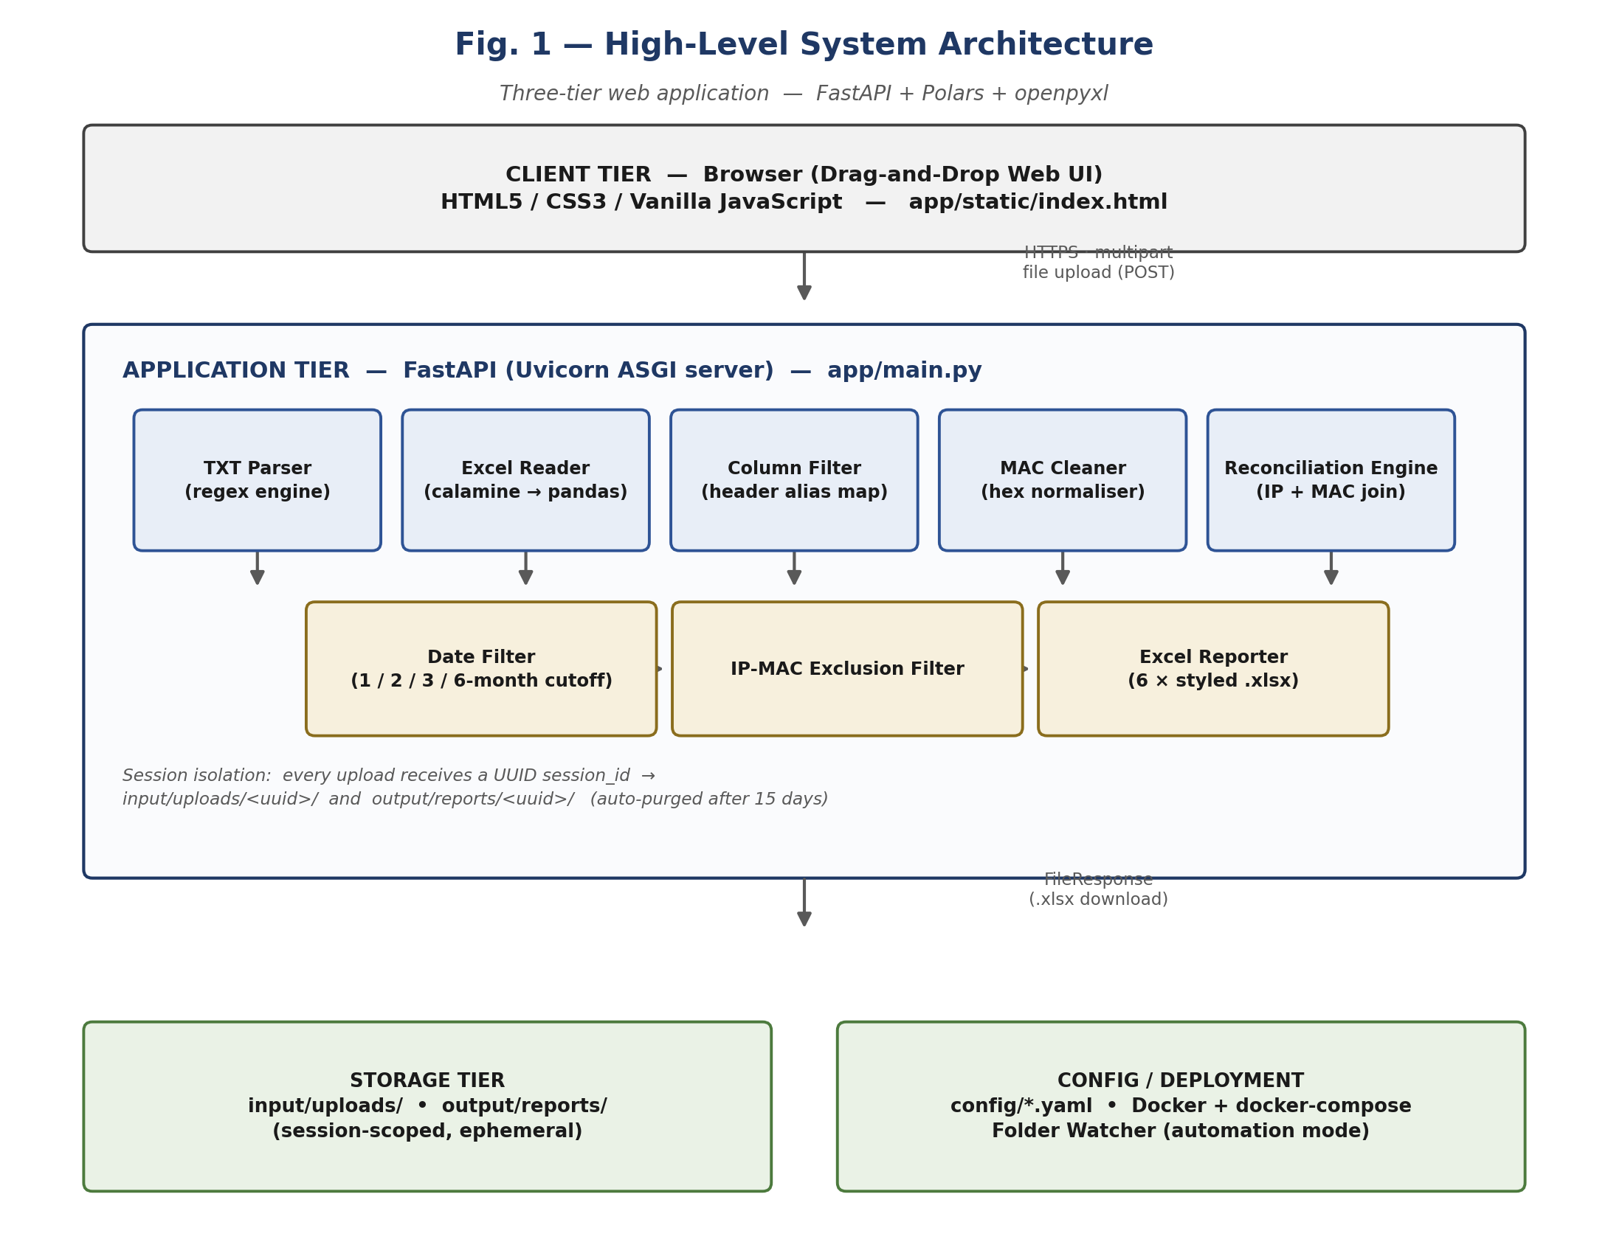
Figure 1: High-level three-tier system architecture.

4.3 Module Map
Inside the second layer, the code is split into separate folders under app/ — parsers, filters, comparators, reports, utils, core, and watcher — each with one clear job. This is what makes the automated tests in Chapter 7 possible: every module can be tested on its own, without needing to run the full web server.
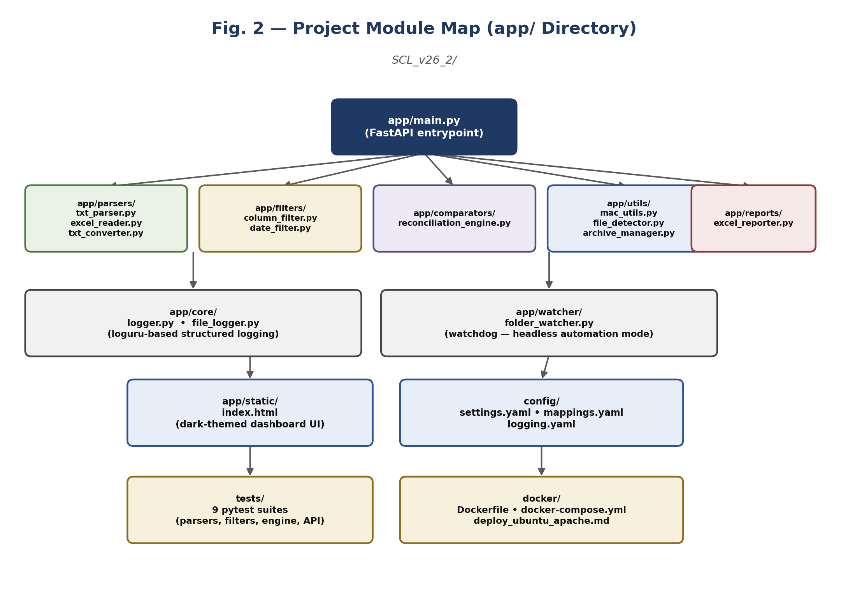
Figure 2: Project module map showing the app/ package structure.

4.4 End-to-End Data Flow
Figure 3 follows a single upload request from the moment the three files reach the server, to the moment the six Excel reports are saved to disk. Each box in this diagram is one step inside the upload_files() function in app/main.py, shown in the exact order they run.
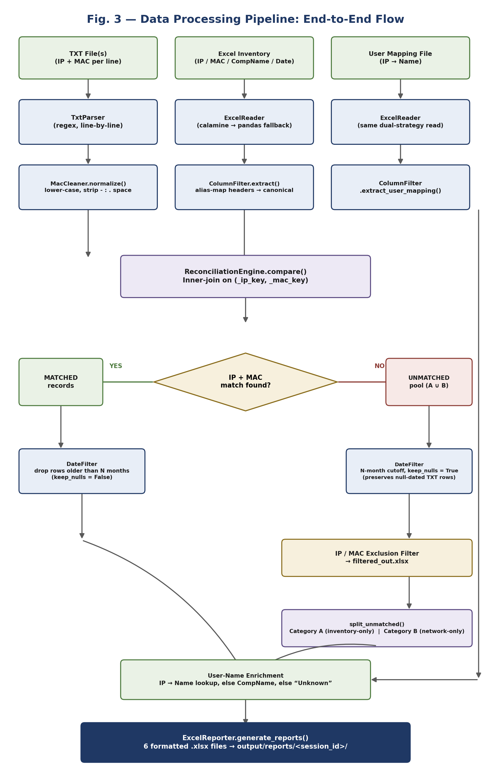
Figure 3: Detailed data-processing pipeline, from raw file upload to final Excel reports.

4.5 Matching & Categorisation Logic
The core of the system is a single join between the TXT data and the inventory data, matched on a cleaned-up IP key and a cleaned-up MAC key (hex characters only, lower case). Any row that does not find a match on either side goes into one shared “unmatched pool”, which is then split again by checking each row against both original files separately. Doing this two-step split — instead of just reusing the first round of matching — makes sure Category A and Category B always add up exactly to the unmatched pool, even after the date filter has removed some rows from it.
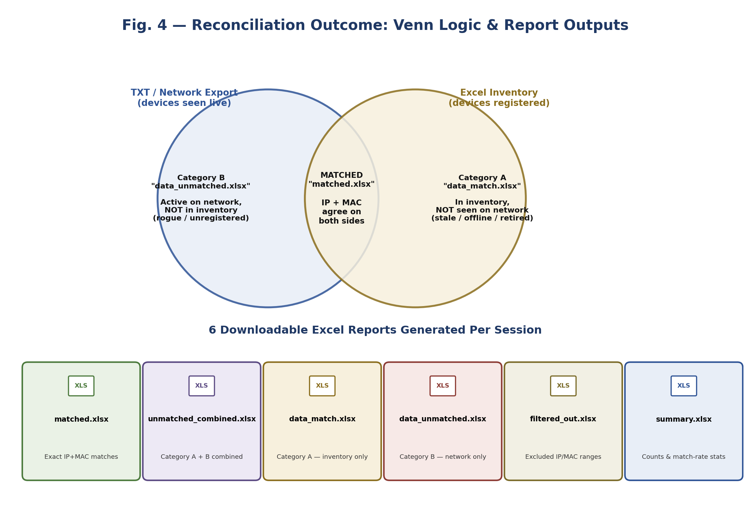
Figure 4: Venn-diagram view of the three reconciliation outcomes and the six report files they map to.

4.6 Deployment Architecture
For live use at SCL, the FastAPI service runs inside a Docker container on an Ubuntu server, with Apache2 sitting in front of it as a reverse proxy on ports 80/443, forwarding requests to the app’s internal port 8000. Four folders on the host machine — uploads, reports, archive, and logs — are linked into the container, so the data is not lost if the container restarts, and it can be backed up separately from the app itself.
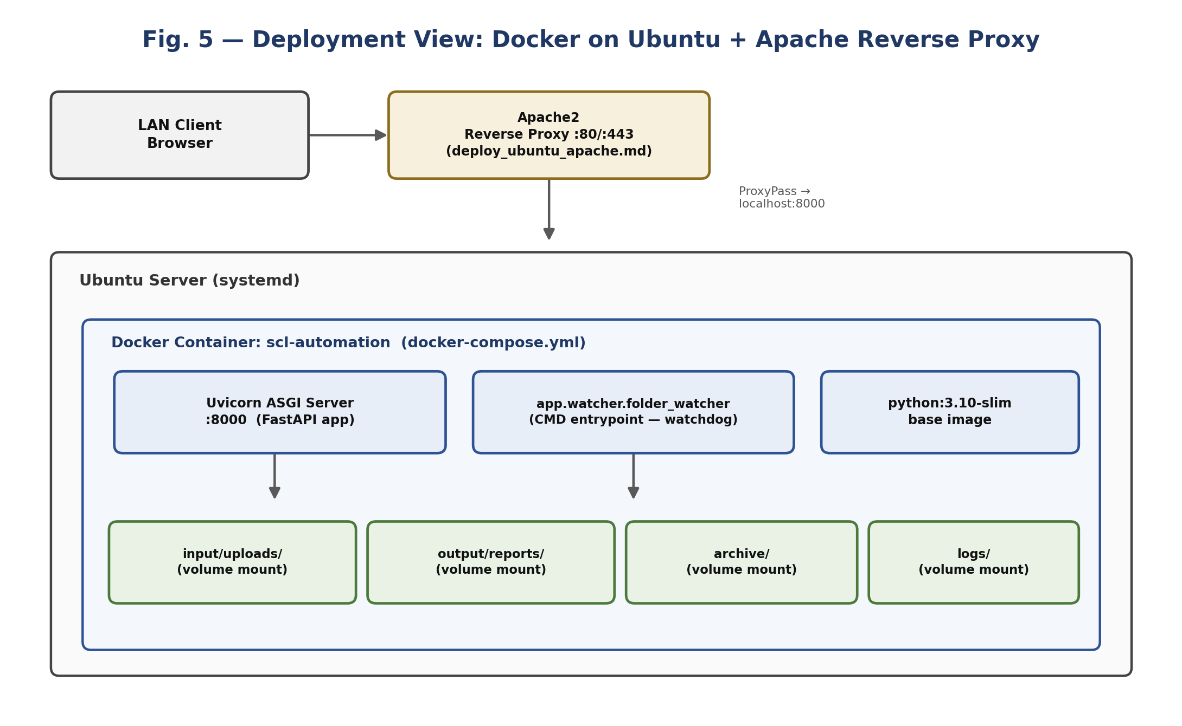
Figure 5: Deployment view: Docker container behind an Apache reverse proxy on Ubuntu.

4.7 Session Isolation Design
Every time someone calls POST /upload, the system creates a fresh random session ID (a UUID) before touching any files. The three uploaded files are always saved with fixed, safe names (network_export.txt, inventory.xlsx, user_mapping.xlsx) inside a folder named after that session ID — never using the file name the user’s browser sent. This closes off a common security issue where a bad file name could be used to write files outside the intended folder. The six generated reports are saved the same way, and every download link checks that the session ID actually looks like a real UUID before using it, rejecting anything suspicious with an error.

4.8 Database Design
This system does not use a database. Every session’s data simply lives as files on disk for 15 days. After that, a background task that starts when the server boots up checks for old session folders and deletes them automatically. This keeps things simple — there is no database server to install, update, or back up — and it makes sense here because reports are meant to be downloaded and used soon after they are created, not searched through later inside the tool.

Chapter 5. Implementation

5.1 Project Structure
The code is organised as a normal Python package, with the main app living in app/, settings in config/, automated tests in tests/, and Docker files in docker/. This section walks through each part of the code, in the same order the data actually moves through the pipeline.

5.2 TXT Parsing — app/parsers/txt_parser.py
Instead of expecting a fixed column layout, TxtParser reads the file line by line using two regular expressions — one to find an “ip-address” label, and one to find a “mac-address” label. This means it does not matter what extra text surrounds these fields in the file. Every MAC address found is immediately converted to lower case with no separators, right at this first step.
app/parsers/txt_parser.py
self.ip_pattern = r'ip-address\s+([\d\.]+)'
self.mac_pattern = r'mac-address\s+([0-9A-Fa-f:\-\.]+)'

for line_no, line in enumerate(file, start=1):
ip_match = re.search(self.ip_pattern, line, re.IGNORECASE)
mac_match = re.search(self.mac_pattern, line, re.IGNORECASE)
if ip_match:
ip = ip_match.group(1)
mac = mac_match.group(1).lower().replace('-','').replace(':','')...
records.append({'IP Address': ip, 'MAC Address': mac})

5.3 Excel Reading — app/parsers/excel_reader.py
Real Excel files can be unpredictable — some are slightly corrupted, some use the older .xls format, and some have merged or blank header cells that create odd “Unnamed: N” columns. ExcelReader deals with this using a two-step approach: it first tries a fast reading engine called calamine, and only if that fails, it falls back to pandas with the right engine for the file type (openpyxl for .xlsx, xlrd for old .xls files). Every cell is read as plain text first, to avoid Excel guessing the wrong data type.
app/parsers/excel_reader.py
try:
df = pl.read_excel(file_path, engine='calamine')
df = self._drop_unnamed(df)
return self._sanitize_safe(df, file_path)
except Exception as e:
logger.warning(f'calamine failed: {e} — trying pandas fallback')
...
pandas_df = pd.read_excel(file_path, engine='openpyxl', dtype=str)
Every table that comes out of this module also passes through a cleanup function called _sanitize(), which turns every column into plain text, removes extra spaces, and strips out a hidden character called a BOM that sometimes appears at the start of Excel files. This sounds like a small detail, but it actually broke exact matches earlier in the project, because a few inventory files had this hidden character on their first column name.

5.4 Column Alias Normalisation — app/filters/column_filter.py
Instead of keeping a huge list of every possible way a header could be spelled, ColumnFilter cleans up each header first — turning it to lower case and removing spaces, hyphens, underscores, and dots — and then looks up the cleaned version in a small dictionary. This means “IP-Address”, “ip_address”, “IP. Address”, and “IP Address” all turn into the exact same lookup key, so one dictionary entry is enough for all of them.
app/filters/column_filter.py
@staticmethod
def _normalize(header: str) -> str:
key = header.strip().lower()
key = re.sub(r'[\s\-_./]+', '', key)
return key

COLUMN_MAPPING = {
'ipadd': 'IPAdd', 'ipaddress': 'IPAdd', 'ip': 'IPAdd',
'macaddress': 'MAC Address', 'macaddr': 'MAC Address', 'mac': 'MAC Address',
'compname': 'CompName', 'computername': 'CompName', 'hostname': 'CompName',
...
}
A similar dictionary, USER_MAPPING_COLUMN_MAPPING, does the same job for the third file (the IP-to-Name sheet). If neither an IP-like column nor a Name-like column can be found at all, the code raises a clear error, which the API turns into an easy-to-understand HTTP 422 response.

5.5 MAC Normalisation — app/utils/mac_utils.py
This is a small, focused helper that makes sure every MAC address ends up in one standard format — lower case with no separators — no matter how it was originally written. So “AA:BB:CC:DD:EE:FF”, “aabb.ccdd.eeff”, and “AA-BB-CC-DD-EE-FF” all become the exact same value before comparison.
app/utils/mac_utils.py
class MacCleaner:
@staticmethod
def normalize(df, column):
return df.with_columns(
pl.col(column).cast(pl.Utf8).str.to_lowercase()
.str.replace_all('-', '').str.replace_all(':', '')
.str.replace_all('.', '', literal=True).str.replace_all(' ', '')
.alias(column)
)

5.6 Reconciliation Engine — app/comparators/reconciliation_engine.py
This is the most important part of the whole project. The compare() function first renames both tables so they use the same column names for IP and MAC. It then creates a cleaned-up _ip_key and _mac_key column on both sides (keeping only hex characters in the MAC key, so any leftover punctuation cannot cause a wrong mismatch), and finally runs three join operations to work out the three possible outcomes.
app/comparators/reconciliation_engine.py — compare()
matched = txt_norm.join(
inv_keys_only, left_on=['_ip_key','_mac_key'],
right_on=['_ip_key','_mac_key'], how='inner'
).drop(['_ip_key','_mac_key'])

txt_unmatched_raw = txt_norm.join(
inv_keys_only.select(['_ip_key','_mac_key']),
on=['_ip_key','_mac_key'], how='anti'
)
inv_unmatched = inv_norm.join(
txt_norm.select(['_ip_key','_mac_key']),
on=['_ip_key','_mac_key'], how='anti'
)
A second function, split_unmatched(), works out Category A and Category B again, but this time from the unmatched pool after the date filter has already been applied. It uses “semi” joins, which keep matching rows without creating duplicates, even if there are repeated or blank keys. This fix was added partway through the project, after I noticed that simply reusing the first round of matching could give slightly wrong totals once the date filter had removed some rows. The semi-join approach guarantees that Category A plus Category B always adds up exactly to the size of the filtered pool.
app/comparators/reconciliation_engine.py — split_unmatched()
has_key = (pl.col('_ip_key') != '') | (pl.col('_mac_key') != '')
pool_keyed = pool.filter(has_key) # blank-key rows excluded from either bucket

# semi-join: keeps pool rows whose key exists on the other side,
# WITHOUT duplicating rows even when the other side has repeated keys
category_a = pool_keyed.join(
inv_keys, on=['_ip_key', '_mac_key'], how='semi'
).drop(['_ip_key', '_mac_key'])

category_b = pool_keyed.join(
txt_keys, on=['_ip_key', '_mac_key'], how='semi'
).drop(['_ip_key', '_mac_key'])

5.7 Date Filtering — app/filters/date_filter.py
The real inventory files from SCL stored the “Last AgentCom” date as text, in an inconsistent format (for example, “1/10/25 9:07:18 AM”, sometimes with “IST” or “UTC” added at the end). DateFilter first removes any timezone text, then tries a list of fourteen possible date formats and keeps whichever one manages to correctly read the most rows. It does not just stop at the first format that works on a few rows — an earlier version did that, and it caused a wrong 12-hour-clock format to “win” by matching only a handful of rows, leaving the rest of the column unread.
app/filters/date_filter.py
DATE_FORMATS = [
'%m/%d/%y %I:%M:%S %p', # 1/10/25 9:07:18 AM <- actual data format
'%m/%d/%Y %I:%M:%S %p',
'%d/%m/%y %I:%M:%S %p',
'%Y-%m-%d %H:%M:%S', '%Y-%m-%dT%H:%M:%S', ...
]
for fmt in self.DATE_FORMATS:
attempt = cleaned.str.strptime(pl.Datetime, fmt, strict=False)
if attempt.drop_nulls().len() > best_count:
best_parsed, best_count, best_fmt = attempt, attempt.drop_nulls().len(), fmt
The filter also has a keep_nulls option. For the Matched group, rows with no readable date are removed, since a matched device should have a real last-seen date. For the Unmatched group, rows with no date are kept, because rows that come from the TXT file never have a Last AgentCom value to begin with — removing them here would wipe out every network-only record and Category B would always end up empty.

5.8 Report Generation — app/reports/excel_reporter.py
ExcelReporter takes the six final tables (matched, combined unmatched, Category A, Category B, filtered-out, and a summary) and saves each one as its own styled .xlsx file. It uses openpyxl on top of Polars to add a navy header with white bold text, thin borders on every cell, centred text, a frozen header row, and columns that automatically resize based on their longest value.
app/reports/excel_reporter.py
HEADER_FILL = PatternFill(fill_type='solid', fgColor='1F4E78')
HEADER_FONT = Font(color='FFFFFF', bold=True)

def _format_excel(self, file_path, sheet_name):
wb = load_workbook(file_path); ws = wb.active; ws.title = sheet_name
for cell in ws[1]:
cell.fill = self.HEADER_FILL; cell.font = self.HEADER_FONT
cell.border = self.THIN_BORDER; cell.alignment = self.CENTER_ALIGN
ws.freeze_panes = 'A2'
wb.save(file_path)
Before the file is saved, a function called _attach_user_name() joins the User Mapping sheet onto the records using IP address, filling in “Unknown” wherever no owner is found. This way, every row in every report is ready to act on right away — no one needs to open a fourth spreadsheet just to find out who owns a device.

5.9 API Layer — app/main.py
FastAPI exposes a small, focused set of routes. A POST /upload route accepts the three files (plus an optional second TXT file and a months setting), runs the full pipeline right there in the request, and sends back a JSON summary with a session ID and six report download links. A group of GET /download/{session_id}/{report} routes each serve one specific report. A GET /health route checks that the server is alive. And the dashboard itself is served from /.
Endpoint | Method | Purpose
/ | GET | Serves the dashboard UI (index.html)
/health | GET | Liveness / version check
/upload | POST | Accepts 3 files + months filter, runs the full pipeline
/download/{id}/matched | GET | Downloads matched.xlsx for a session
/download/{id}/unmatched | GET | Downloads the combined unmatched report
/download/{id}/inv_unmatched | GET | Downloads Category A (inventory-only)
/download/{id}/txt_unmatched | GET | Downloads Category B (network-only)
/download/{id}/summary | GET | Downloads the summary statistics workbook
/download/{id}/filtered_out | GET | Downloads records excluded by IP/MAC rules
The /upload route ties every module covered in this chapter into one simple, step-by-step pipeline. The whole thing is wrapped in an error handler, so that if anything unexpected goes wrong while reading a file, the user gets a clean error message instead of a confusing stack trace:
app/main.py — POST /upload (simplified)
@app.post('/upload')
async def upload_files(txt_file: UploadFile, inventory_file: UploadFile,
mapping_file: UploadFile, months: int = 3):
session_id = str(uuid.uuid4())
session_dir = UPLOAD_DIR / session_id
session_dir.mkdir(parents=True, exist_ok=True)

txt_path = save_upload(txt_file, session_dir / 'network_export.txt')
inv_path = save_upload(inventory_file, session_dir / 'inventory.xlsx')
map_path = save_upload(mapping_file, session_dir / 'user_mapping.xlsx')

txt_df = TxtParser().parse(txt_path)
inv_df = ColumnFilter().extract(ExcelReader().read(inv_path))
map_df = ColumnFilter().extract_user_mapping(ExcelReader().read(map_path))

result = ReconciliationEngine().compare(txt_df, inv_df)
reports = ExcelReporter().generate_reports(result, map_df, months, session_id)
return {'status': 'success', 'session_id': session_id, **reports}

5.10 Frontend — app/static/index.html
The dashboard is a single HTML file with a dark, modern theme — soft blurred background shapes, a clean Google font called Inter — and plain JavaScript for the drag-and-drop upload boxes, the month filter, and the results panel that shows the six report cards once the /upload response comes back. There is no frontend framework or build step involved, so the whole browser side of the app is just one file that FastAPI serves directly.
app/static/index.html — upload handler (JavaScript)
async function submitFiles() {
const form = new FormData();
form.append('txt_file', txtInput.files[0]);
form.append('inventory_file', inventoryInput.files[0]);
form.append('mapping_file', mappingInput.files[0]);
form.append('months', monthsSelect.value);

const res = await fetch('/upload', { method: 'POST', body: form });
const data = await res.json();
renderReportCards(data.session_id, data.reports); // populate download links
}

5.11 Logging & Configuration
app/core/logger.py wraps a library called Loguru to give every module the same consistent way of logging messages. Meanwhile, config/settings.yaml, config/mappings.yaml, and config/logging.yaml keep settings like retention days, alias dictionaries, and log detail level outside the code, so they can be changed without touching any Python file. Every step of the pipeline logs how many rows it had before and after running, which was a huge help while debugging the date-parsing and column-matching problems described in Chapter 6.
config/settings.yaml
retention:
uploads_days: 15
reports_days: 15
cleanup_interval_hours: 24

reconciliation:
default_months_filter: 3
allowed_months_filter: [1, 2, 3, 6]

excel:
header_fill_color: '1F3864'
freeze_header_row: true

5.12 Automation Mode — app/watcher/folder_watcher.py
Apart from the web dashboard, the project also supports a fully automatic mode using a library called watchdog. By default, the Docker image runs app.watcher.folder_watcher, which watches a chosen folder for new files and runs the same reconciliation pipeline automatically, saving reports into an archive/ folder. This mode is meant for scheduled, unattended runs — for example, a nightly export — where no one is around to use the browser dashboard.

Chapter 6. Development Journey — From Start to End
This chapter explains how the project was actually built, step by step, including the mistakes and fixes that a finished codebase usually hides. The old, commented-out code still sitting in reconciliation_engine.py and excel_reporter.py is honest proof of this process — new logic was written next to the old code, tested, and only then swapped in.
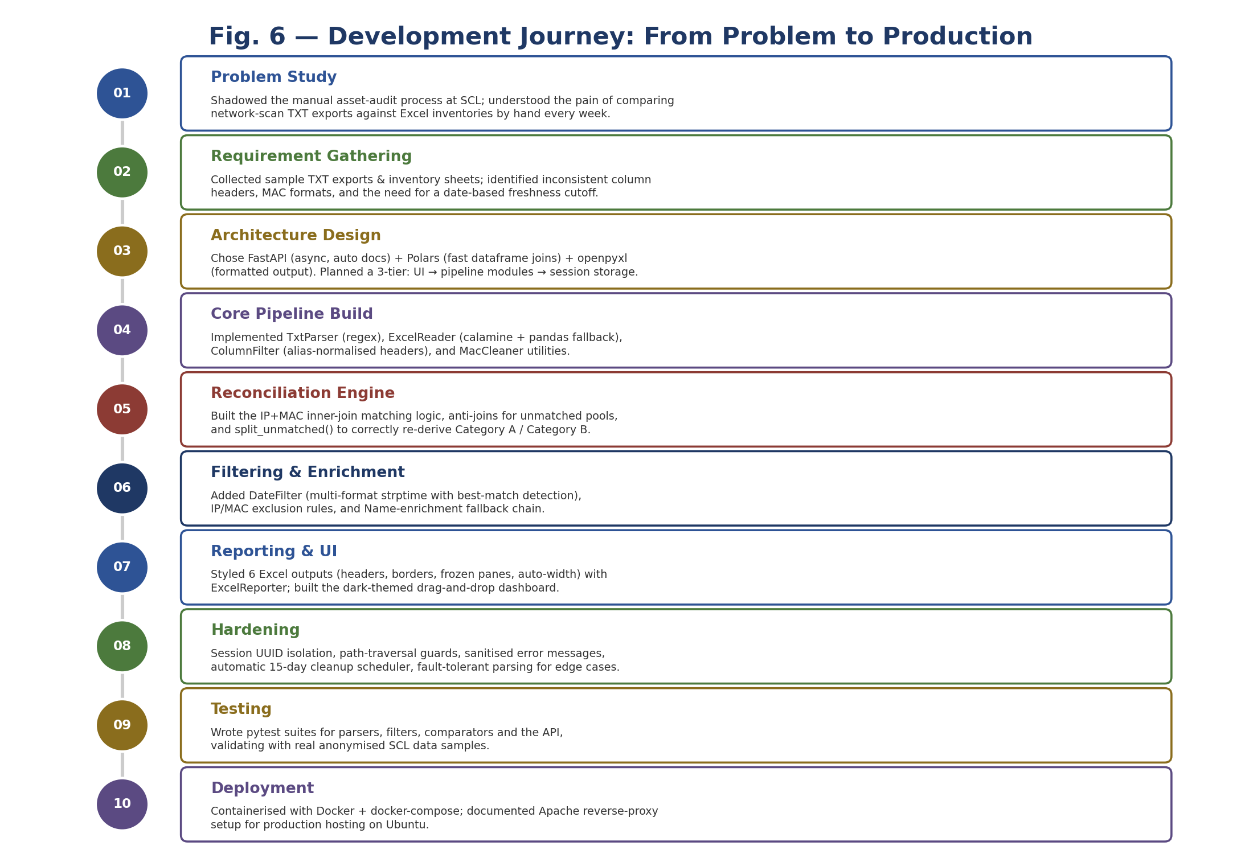
Figure 6: Ten-stage development timeline followed during the project.

6.1 Phase 1 — Understanding the Manual Process
The project did not start with code. It started with watching. I sat with the network team while they did a manual reconciliation, to understand which columns they actually cared about, which formatting problems they had learned to just work around by eye, and which two questions mattered the most to them: “what’s on the network but not in the inventory”, and “what’s in the inventory but not on the network”.

6.2 Phase 2 — Choosing the Stack
FastAPI was chosen over Flask or Django because it supports async requests out of the box, checks incoming files and form data automatically, and creates API documentation on its own — which made the /upload route much easier to work with during development. Polars was chosen over pandas as the main dataframe library because the reconciliation work is mostly about joining large tables, and Polars’ engine handles big joins noticeably faster. Pandas was kept only as a backup inside ExcelReader, for files that the faster calamine engine could not read.

6.3 Phase 3 — Building the Parsing Layer First
Development started at the edges of the pipeline — parsing raw TXT and Excel files — rather than the matching logic in the middle. This is because turning genuinely messy files into clean, correctly typed tables turned out to be harder, and more important to get right, than the joins themselves. The first version of ExcelReader used pandas directly, and it often failed on old .xls files and headers with hidden BOM characters. The current calamine-first, pandas-fallback approach was added only after these failures showed up on real SCL files.

6.4 Phase 4 — The First Working Reconciliation Engine
The first version of the matching engine — still saved as commented-out code at the top of reconciliation_engine.py — used a basic inner-join plus two separate joins to find the unmatched TXT and unmatched inventory rows. This worked fine on its own. But once the date filter was added later in the pipeline, a small bug appeared: filtering the two unmatched groups separately did not always agree with filtering the combined group. This is what led to the split_unmatched() rewrite explained in Section 5.6, which works out both categories again from a single, already-filtered pool using semi-joins.

6.5 Phase 5 — Fighting the Date Format Problem
The single most time-consuming bug in the whole project was about dates. The “Last AgentCom” column came in as plain text, in a 12-hour clock format with AM/PM, and sometimes with “IST” or “UTC” added at the end. An early version of DateFilter tried different date formats in a fixed order and stopped at the first one that did not throw an error. The problem is that Polars does not throw an error for a partial mismatch — it just quietly returns a blank value for rows that do not fit. This meant a wrong 24-hour format could “pass” by accidentally matching a few rows, while leaving most of the column unread, and nobody would know. The fix — trying every possible format and keeping whichever one reads the most rows correctly — is now written as a clear comment in the code, as a warning for the future.

6.6 Phase 6 — Hardening for Multi-User Use
Once the pipeline worked correctly for one run at a time, the next step was making it safe for many people to use it at once. This meant adding UUID session folders, checking that every download request has a valid session ID, always using fixed file names for uploads to avoid path-traversal attacks, and cleaning up error messages so that internal server file paths are never shown to the user.

6.7 Phase 7 — Styling the Output and the UI
Once the backend logic was solid, the focus shifted to making the output easy to use for someone non-technical: styled Excel headers, frozen panes, auto-sized columns in ExcelReporter, and a polished, dark-themed drag-and-drop dashboard on the frontend — so the tool would feel like a finished product, not just a developer script.

6.8 Phase 8 — Testing, Containerising, and Documenting Deployment
The last phase added the pytest test suite covering the parsers, filters, the matching engine, and the API; wrote the Dockerfile and docker-compose.yml so the whole app could be started with one command; and documented the Apache setup needed to run it on a real Ubuntu server. This completed the journey from a local script to a tool that can actually be deployed and used by a team.

6.9 Key Lessons Learned
- Real-world data almost never matches the neat format you planned for on paper. The alias-matching in ColumnFilter and the multi-format date parser in DateFilter both exist because real files broke earlier, stricter assumptions.
- A quiet, partial failure (like a date silently turning into a blank value instead of raising an error) is more dangerous than a loud crash, because it can produce output that looks correct but is actually wrong.
- Splitting the pipeline into small, single-purpose pieces that can be tested on their own made it much easier to find and fix the date-filter and category bugs described above.
- Security details (like path traversal, or leaking file paths through error messages) are easy to miss in a first working version, and need a separate pass to fix properly.

Chapter 7. Testing

7.1 Testing Strategy
Testing follows the same idea as the rest of the project: each part of the pipeline is tested on its own with pytest, before it is trusted inside the full FastAPI app. The tests folder has nine test files that together cover parsing, filtering, matching, report generation, and the API. They use anonymised samples of real SCL data, loaded through a small helper called FileDetector that finds the latest sample TXT/Excel file in a fixtures folder.

7.2 Test Suite Overview
Test File | What It Verifies
test_parser.py | TxtParser correctly extracts IP and MAC pairs from raw export lines, including mixed separator styles.
test_converter.py | TXT-to-structured conversion utilities behave correctly on sample exports.
test_inventory_loader.py | ExcelReader loads .xlsx/.xls files correctly and drops blank/Unnamed columns.
test_filter.py / test_date_filter.py | ColumnFilter alias resolution and DateFilter’s multi-format cutoff logic across 1/2/3/6-month windows.
test_compare.py / test_comparison.py | ReconciliationEngine’s matched/unmatched output and split_unmatched() category totals.
test_reports.py | ExcelReporter produces correctly structured, styled workbooks.
test_api.py | FastAPI endpoints respond correctly, including session isolation and invalid-session-ID rejection.

7.3 Representative Test Cases
# | Test Case | Expected Result | Status
1 | Parse TXT line with colon-separated MAC | MAC normalised to lower-case, no separators | Pass
2 | Read a legacy .xls inventory file | Falls back to xlrd engine and loads all rows | Pass
3 | Header 'IP-Address' vs 'ip_address' vs 'IPAdd' | All resolve to canonical 'IPAdd' column | Pass
4 | Date string with AM/PM and IST suffix | Correctly parsed and compared against cutoff | Pass
5 | Record present in both TXT and Excel | Appears exactly once in matched.xlsx | Pass
6 | Record only in TXT (not in inventory) | Appears in Category B, not Category A | Pass
7 | Record only in inventory (not seen live) | Appears in Category A, not Category B | Pass
8 | Blank IP and MAC row | Excluded from both categories (no false match) | Pass
9 | session_id with path-traversal payload ('../../etc') | HTTP 400 Invalid session ID format | Pass
10 | Download request for expired/unknown session | HTTP 404 with a clear, non-leaking message | Pass

7.4 Manual & Integration Testing
Besides the automated tests, the full pipeline was also tested by hand through the browser dashboard, using real (anonymised) SCL inventory and network-export files of different sizes. This confirmed that the match counts, category totals, and date-filtered summaries were all correct, by manually checking a sample of rows.

Chapter 8. Deployment

8.1 Containerisation
The whole application is packaged as one Docker image, built on top of python:3.10-slim, with all dependencies installed from requirements.txt and the full app/ folder copied in. docker-compose.yml connects four folders from the host machine — input/, output/, archive/, and logs/ — so uploaded files, reports, automation runs, and logs all stay safe outside the container and survive even if the container is rebuilt.
docker/Dockerfile
FROM python:3.10-slim
WORKDIR /app
COPY requirements.txt .
RUN pip install --default-timeout=1000 --no-cache-dir -r requirements.txt
COPY . .
CMD ["python", "-m", "app.watcher.folder_watcher"]
Bringing the whole stack up is a single command:
Terminal
docker compose -f docker/docker-compose.yml up --build -d

8.2 Production Hosting — Ubuntu + Apache
For normal browser use, deploy_ubuntu_apache.md explains how to run the FastAPI service through Uvicorn on an internal port (8000), and put Apache2 in front of it as a reverse proxy, handling the usual HTTP/HTTPS ports (80/443) for the local network. This keeps the actual application hidden from direct access, and lets Apache take care of security certificates, access logs, and any other standard protections the organisation already uses on its web servers.

Figure 7: Production deployment topology used for hosting the application at SCL.

8.3 Configuration Management
The retention rules, column-alias dictionaries, and log detail level all live outside the code, in config/settings.yaml, config/mappings.yaml, and config/logging.yaml. This means simple changes — like changing the 15-day cleanup window — do not need any code changes or a new deployment.

8.4 Automated Cleanup
A background task, which starts automatically when the server boots up, checks both the uploads and reports folders once every 24 hours and deletes any session folder older than the configured retention period (15 days by default). This keeps disk space under control without anyone needing to clean it up by hand.

Chapter 9. Results & Discussion

9.1 Functional Outcome
The finished system takes the three required files and, within seconds, produces the six categorised Excel reports described in Chapter 4 — turning what used to be a multi-hour manual VLOOKUP job into a single drag-and-drop upload. Every report is ready to share right away: headers are styled, columns are sized correctly, and every record has an owner name attached wherever the user-mapping file has one.

9.2 Sample Session Response
A successful call to /upload sends back a JSON summary, which the frontend shows as live statistics cards. Here is what a typical (anonymised) response looks like:
Sample response — POST /upload (JSON)
{
"status": "success",
"session_id": "a1b2c3d4-....",
"months_filter": 3,
"txt_records": 4820,
"inventory_records": 5104,
"matched": 4390,
"unmatched_after_filter": 812,
"excluded_by_date_filter": 96,
"filtered_out_count": 41,
"reports": { "matched": "/download/.../matched", ... }
}

9.3 Impact on the Manual Process
- Time saved: a reconciliation cycle that used to take several hours of manual VLOOKUP work now finishes in seconds of processing time, plus a few minutes to upload and review.
- Better accuracy: cleaning up MAC/IP formats before comparing them gets rid of the false-mismatch errors that manual exact-match formulas were prone to.
- More clarity: splitting results into two clear categories (network-only vs inventory-only) gives the team a direct, useful answer instead of one confusing “not found” bucket.
- Easy auditing: every run is timestamped and kept in its own session, and the summary and filtered-out reports give a clear record of exactly what was left out and why.

9.4 Known Limitations
- The system only matches on IP + MAC exactly; it does not try fuzzy or partial matching (for example, matching on MAC alone when the IP has changed through DHCP), which could be a useful addition later.
- Since there is no database, the tool cannot currently show historical trends across many past sessions.
- Very large inventory files, well beyond what was tested during development, have not been benchmarked yet, although Polars’ fast joins should scale well beyond the current pandas fallback path.

Chapter 10. Conclusion & Future Scope

10.1 Conclusion
This project set out to replace a slow, error-prone, manual Excel process with a proper, self-hosted web application — and it does exactly that. By treating parsing, cleaning, matching, filtering, and reporting as separate, testable steps, the system stays easy to maintain, while still handling the messiness of real network and inventory data: inconsistent MAC formats, changing column headers, and inconsistent date strings that would silently break a simple exact-match approach. Beyond the core matching logic, the project also needed — and now has — the kind of engineering discipline a real production tool needs: session isolation for multiple users, careful error handling, automatic cleanup, a documented deployment process, and automated tests.
Working on this project from start to end — from sitting with the network team to understand their manual process, to debugging a tricky date-parsing bug, to writing the Docker and Apache deployment docs — gave me hands-on experience across the full stack of building a real internal tool: backend API design, fast data processing with Polars, careful file handling, frontend UI work, automated testing, and containerised deployment.

10.2 Future Scope
- Add a MAC-only fallback match, for devices whose IP address has changed (for example, through DHCP) but whose MAC address has stayed the same.
- Add a lightweight database (like SQLite or DuckDB, both already available) to allow trend reports across many past reconciliation runs.
- Add login and role-based access to the web dashboard, since right now it only relies on network-level access control.
- Build a small dashboard for the automatic folder-watcher mode, showing recent unattended runs and their stats, without needing to check the archive/ folder by hand.
- Add email or chat notifications to alert the network team automatically when the number of unregistered (Category B) devices crosses a certain limit.
- Support more network-export formats beyond the current TXT layout, using a pluggable parser design.

References
[1] FastAPI Documentation — https://fastapi.tiangolo.com/
[2] Polars User Guide — https://docs.pola.rs/
[3] openpyxl Documentation — https://openpyxl.readthedocs.io/
[4] Pandas Documentation — https://pandas.pydata.org/docs/
[5] Docker Documentation — https://docs.docker.com/
[6] Pytest Documentation — https://docs.pytest.org/
[7] Apache HTTP Server mod_proxy Documentation — https://httpd.apache.org/docs/2.4/mod/mod_proxy.html
[8] Project Source Code Repository — SCL_v26_2, GitHub: github.com/RavikantBedi/SCL_v26_2

